PF LAB 10 TASKS

Name: Muhammad Rohaan Roll No: 25K-0026
Date: 18th November, 2025 Section: BAI-1A

-> TASK #1:

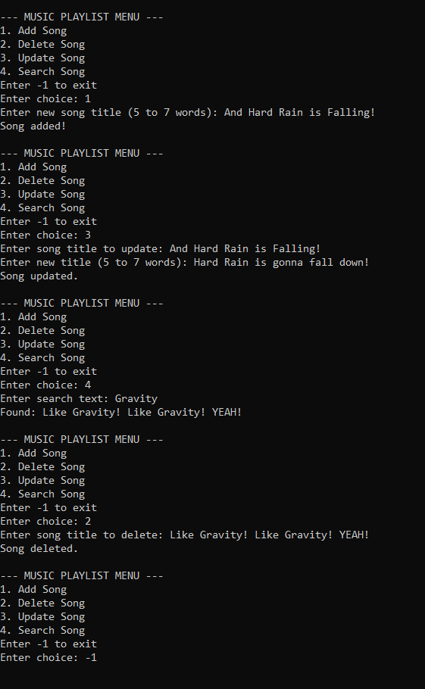
-> TASK #2:

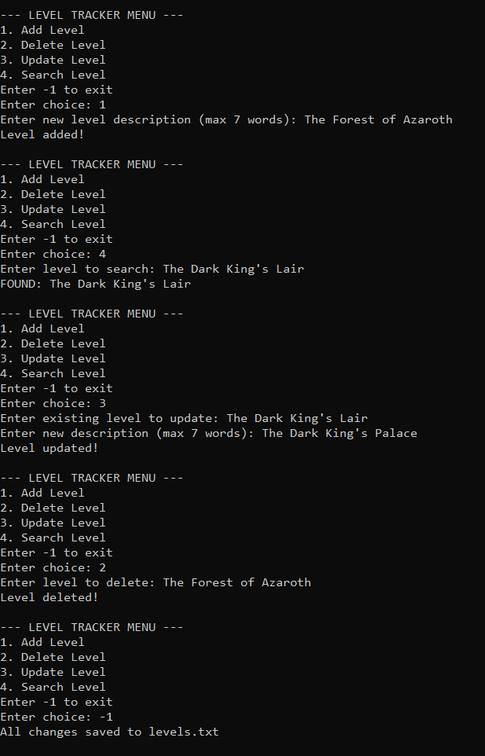
______________________________________________________________________________
-> TASK #3:

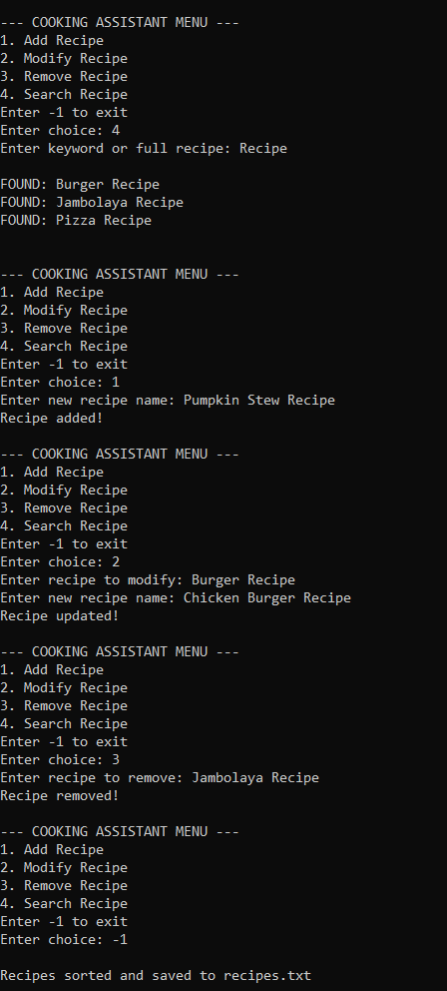
-> TASK #4:

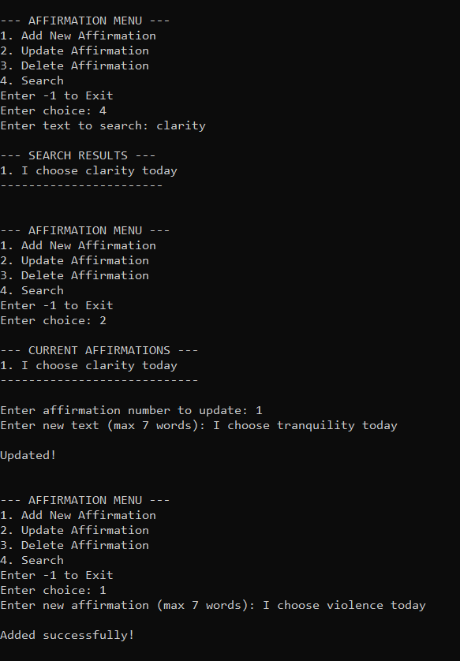

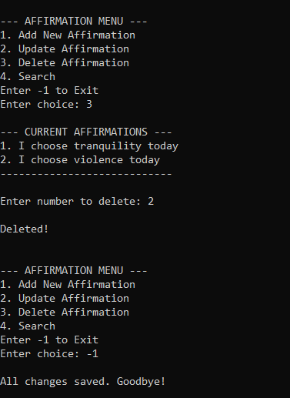

______________________________________________________________________________

-> TASK #5:

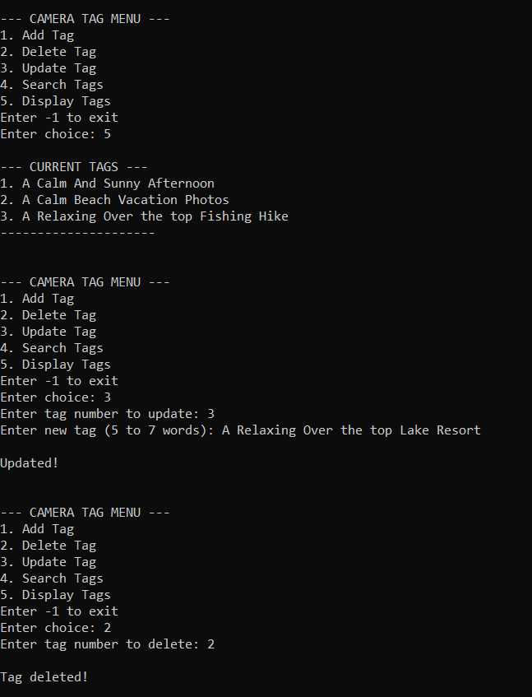

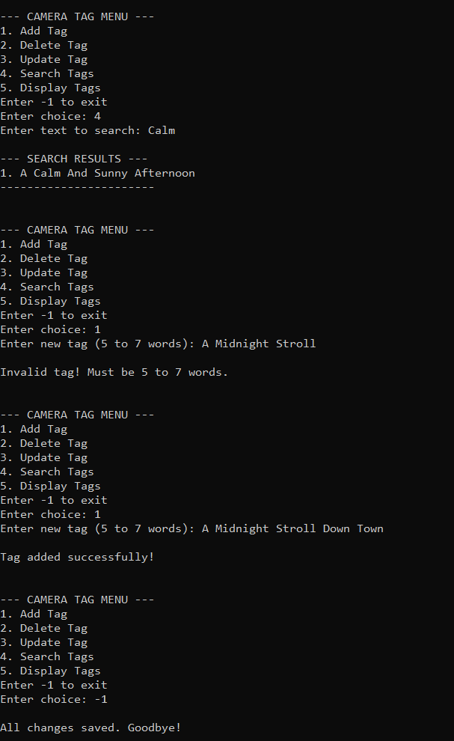

______________________________________________________________________________

-> TASK #6:




